Check List for WFH

Zeppelin Prod - <http://usnencpl075.nmcorp.nissan.biz:9995/> - To check daily base table loads in Bigdata Environment.

DIH Prod - <http://10.78.11.31:18080/dih-console/login.jsp>

DIH Non Prod - <http://10.78.11.32:18080/dih-console/login.jsp>

Oozie Prod - <http://usnencpl075.nmcorp.nissan.biz:11000/oozie/>

Oozie Stage - <http://usnencpl077.nmcorp.nissan.biz:11000/oozie/>

Ambari Prod - <http://usnencpl075.nmcorp.nissan.biz:8080/#/login>

Tableau - <https://tableau.na.nissan.biz/#/site/TCS/datasources>

Service Now - <https://nnanissan.service-now.com/>

EQUIP Prod Application- <https://datamgtanalytics.na.nissan.biz/>

Confluence - <https://confluence.na.nissan.biz/>

(master deployment log - <https://confluence.na.nissan.biz/pages/viewpage.action?spaceKey=TCSFQI&title=EQUIP+Master+Deployment+Log>)

Jira - <https://jira.na.nissan.biz/>

Zoom Meeting - <https://nissan-usa.zoom.us/j/8647358496> - IPS Daily standup

SQL Developer:

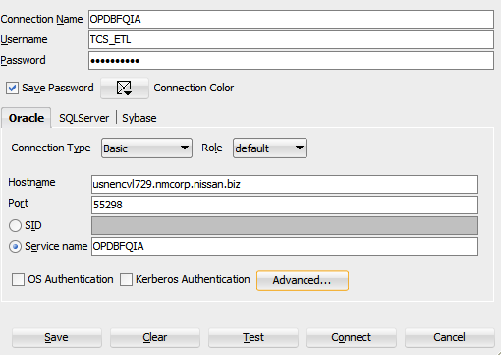

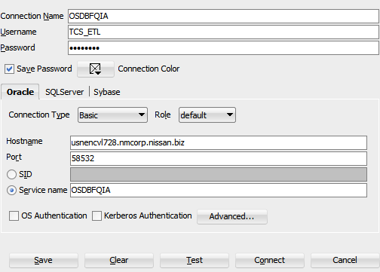

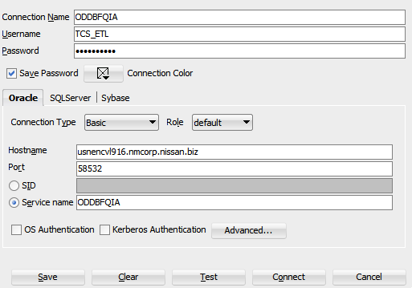

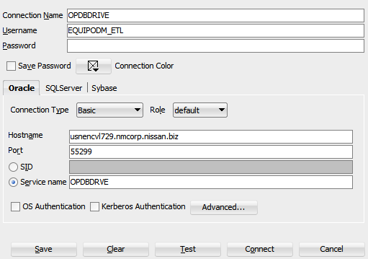

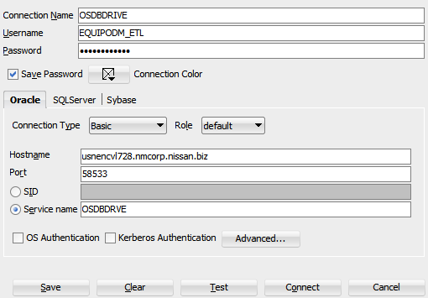

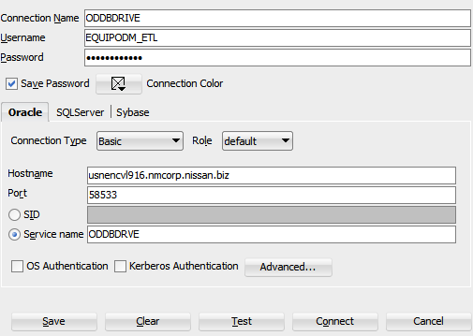

Informatica Configurations :

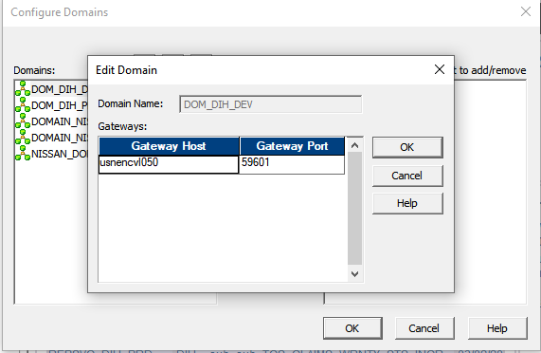

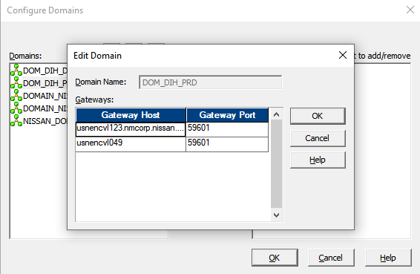

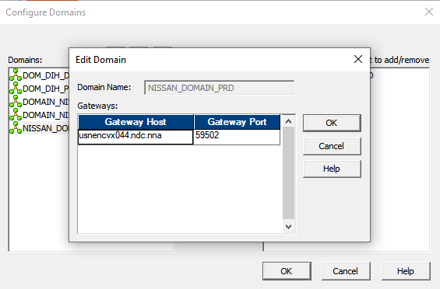

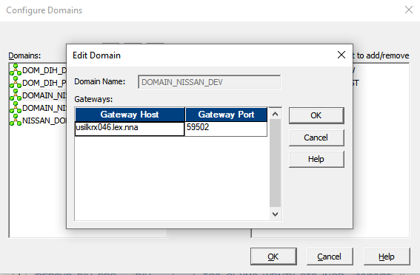

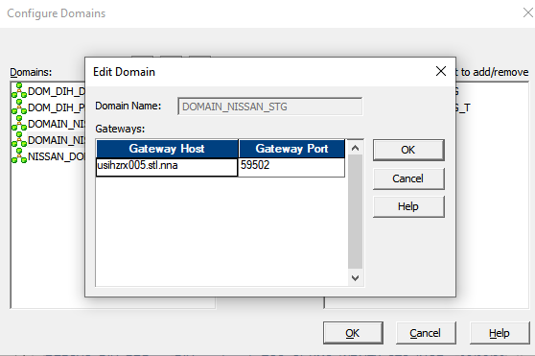

UNIX IPs: – port 22

Informatica Prod - 10.78.11.21

Dev - 10.78.39.67

Stage - 10.78.39.100

Hive Dev - 10.79.32.133

Prod - 10.79.32.129

Stage - 10.79.32.131